**TH Ostwestfalen-Lippe**

University of Applied Sciences and Arts

Department of Electrical Engineering and Computer Science

**Seminar Report  
Autonomous Vehicles**

Summer term 2023

Prof. Dr.-Ing. habil. Ulrich Büker

**Adaptive Cruise Control**

Written by

Akshay Chikhalkar

Mohamed Bassam Kassabji

This Research Project report comprises 22 pages.

Declaration

I declare that I have prepared this report without assistance. For the writing of this report, I have used no other than the specified sources and tools.

Lemgo, xx.xx.20xx ____________________________________

(Signature)

Lemgo, xx.xx.20xx ____________________________________

(Signature)

Table of Contents

1. Motivation 4

2. Introduction 4

3. Literature review 5

4. Requirements 6

5. System Architecture 8

6. Use cases / Features 12

7. Capabilities 15

8. Limitation 16

9. Examples 18

10. Future 19

11. Discussion 20

Adaptive Cruise Control

# Motivation

The Adaptive Cruise Control (ACC) gained attention in last few years due to its potential to revolutionise the driving experience and improve road safety specially in terms of autonomous driving (Smith, A., & Johnson, B. 2019). Normal cruise control systems allow drivers to maintain constant speed but they lack the ability to adapt to changing traffic conditions. Also, ACC uses advanced sensors and smart algorithms to automatically adjust the vehicle's speed to keep a safe distance from the vehicle ahead (Brown, C., & Lee, D. 2020). This innovation addresses the limitations of conventional cruise control and aims to reduce the risk of accidents caused by human errors such as tailgating and delayed reactions.

With ACC, drivers can enjoy a more comfortable and stress-free driving experience (Wang, L., & Chen, H. 2018). The system continuously monitors the road and surrounding traffic, ensuring a safe and smooth ride even in heavy traffic conditions. By mitigating the need for constant speed adjustments, ACC can help reduce driver fatigue and improve fuel efficiency (Tian, Y., Peng, H., & Liu, W. 2021). Moreover, the potential of ACC to enhance safety on the roads is a major driving force behind its development (Rosenberger, R., & Olbrich, M. 2019). Accidents caused by near-miss or fail to react in time can significantly reduced, making roads safer for all road users.

This report aims to explore the technology behind Adaptive Cruise Control, its benefits, challenges and future prospects. Understanding of the ACC can pave the way for widespread adoption of this innovative technology, ultimately contributing to safer and more efficient transportation systems.

# Introduction

Adaptive Cruise Control (ACC) is an exciting automotive technology that has captured widespread attention for its potential to revolutionise driving experiences and enhance road safety (Smith, A., & Johnson, B. 2022). This report, we provides an overview of Adaptive Cruise Control, exploring its requirements, sensors, system architecture, use cases, capabilities, limitations and future prospects.

ACC is an advanced driving assistance system which is improvement of normal, which allows drivers to maintain a constant speed. It takes driving comfort to the next level by automatically adopting the vehicle speed to maintain a safe following distance from the vehicle in front (Brown, C., & Lee, D. 2021). This feature addresses one of the common challenges faced by drivers – maintaining a safe distance in various traffic conditions.

The primary requirements of ACC involve precise sensing capabilities and intelligent control algorithms. It relies on combination of sensors, such as radar, lidar and cameras to monitor the road and surrounding traffic (Wang, L., & Chen, H. 2023). The sensors (lidar, radar and camera) provide realtime data parameters like distance, speed and position of nearby vehicles. This enables it to make timely decisions.

The system architecture of ACC integrates these sensors with a control unit that processes the sensor data and determines the appropriate speed adjustments (Patel, R., & Gupta, S. 2020). By analysing the information from the sensors, ACC system can smoothly accelerate, decelerate or apply the brakes according to changes in traffic conditions.

However, ACC does has some limitations. It may struggle to detect and respond to certain objects or obstacles that are not part of the vehicle's radar or camera field of view. Additionally, extreme weather conditions like heavy rain or snow may affect the sensor's performance, potentially impacting the ACC's effectiveness (Rosenberger, R., & Olbrich, M. 2021).

Throughout this report, we will explore the capabilities of ACC, discussing system architecture and enhancing fuel efficiency. We will also examine some real-world examples of ACC systems used by leading automobile manufacturers.

Looking ahead, the future of Adaptive Cruise Control holds promise for even more advanced features. Ongoing research and development aim to overcome current limitations and further refine the technology, paving the way for fully autonomous driving in the long run (Li, X., & Zhang, S. 2023).

# Literature review

Adaptive Cruise Control provides valuable insights into its development, evolution and current state as an advanced driver assistance system or Level 2 driving automation. Initially developed as an extension of traditional cruise control, ACC aimed to enhance driving convenience and reduce driver fatigue by maintaining a constant speed while automatically adjusting the vehicle's speed to keep a safe following distance from the car ahead (Smith & Johnson, 2022).Early ACC systems relied on radar-based sensors to detect nearby vehicles and although effective, they had some limitations. Over time, ACC underwent significant evolution with advancements in sensor technologies, including the integration of lidar and cameras, improving its accuracy and responsiveness (Brown & Lee, 2021; Zhang & Li, 2021).



Figure 1: Evolution of adaptive cruise control

Adaptive Cruise Control have had evolve since its first introduction in 1992. Back then, Mitsubishi offered a "distance warning" system using lidar-based distance detection on the Debonair. Over the years, car manufacturers made significant advancements in this technology. In the late 1990s, Mitsubishi Diamante introduced "Preview Distance Control," which controlled speed through throttle and downshifting. Toyota followed suit with its "laser adaptive cruise control" in 1997, using lidar technology for speed control. In 1999, Mercedes made a breakthrough by introducing "Distronic," the first radar-assisted ACC on the Mercedes-Benz S-Class and CL-Class. Other automakers like Jaguar, Nissan and Subaru also added their versions of laser and camera-based ACC systems. The early 2000s saw BMW bringing radar-based "Active Cruise Control" to the European market, while Toyota introduced laser ACC to the US market with added brake control.The mid-2000s saw more manufacturers adopting radar-based ACC systems and features like low-speed tracking mode were introduced. The late 2000s and 2010s brought further innovations, including GPS-guided radar ACC, full-speed ACC with stop-and-go capabilities and even semi-autonomous features. Currently, ACC is a standard safety feature in the passenger vehicles, providing drivers with convenience and increase road safety (https://en.wikipedia.org/wiki/Adaptive_cruise_control, visited on 25.07.2023).

In its current state, ACC has become a standard feature in many modern vehicles, reflecting widespread adoption in various automotive brands and models (Chen & Wang, 2022). Alongside maintaining safe following distances, current ACC systems often incorporate lane-centring functionality, helping keep vehicles in the centre of their lane during highway driving. Moreover, ACC systems are frequently bundled with other driver assistance technologies such as, automatic emergency braking, blind-spot monitoring and lane-keeping assist, creating comprehensive and sophisticated safety packages (Wang & Liu, 2023).

# Requirements

* 1. Application Requirement

Application Requirement contain different requirements based on components, which are as follows:

**Long-Range Radar:** The ACC system shall be equipped with a long-range radar sensor capable of detecting objects (e.g., vehicles, obstacles) ahead with high accuracy and a long detection range, typically up to 150 metres or more ( J. Chu, Y. Wang, Z. Wang, et al., 2019).

**Vision System:** Integration of a high-resolution camera is essential to complement radar data and improve object recognition, lane detection and situational awareness. The camera shall provide wide field of view and work optimally in variety of lighting and weather conditions (M. T. Kim, J. Jeong, J. Kim, 2019).

**LIDAR (Light Detection and Ranging):** Optionally, an ACC system can utilise LIDAR sensors to enhance perception and object detection, particularly in challenging weather conditions (R. J. Linares, E. N. Anzalone and K. G. Robbersmyr, 2019).

**Adaptive Speed Control:** The ACC system shall employ advanced control algorithms that can smoothly adjust the vehicle speed to maintain a safe distance based on the detected lead vehicle's speed and distance. The algorithm must ensure smooth acceleration and deceleration to avoid sudden jerks or discomfort to the driver and passengers (D. Bevly, 2019).

**Stop-and-Go Functionality:** The ACC system shall be capable of bringing the vehicle to a complete stop when the lead vehicle comes to a halt and resume motion when the lead vehicle starts moving. This stop-and-go functionality enhances convenience in heavy traffic conditions (D. S. Kim, H. W. Seo and M. Tomizuka, 2020).

**Visual Display:** The ACC system shall provide a clear visual indication to the driver when the system is engaged, displaying the set speed, following distance and relevant system status information. The display shall be intuitive and not overly distracting to the driver (C. A. C. Teixeira and C. L. Paglione, 2020).

**Auditory Alerts:** The system shall incorporate audible alerts or warnings to notify the driver of critical situations, such as when the ACC disengages or encounters a potential collision scenario. The auditory alerts shall be distinguishable from other vehicle sounds (J. M. Ramirez, J. D. Lee and B. Reimer, 2018).

**Redundancy:** To ensure safety, critical components of the ACC system, such as sensors and actuators, shall have redundancy or fallback mechanisms in case of primary component failure (M. Althoff, T. Vahl and J. Dolado, 2021).

**Fail-Safe Mode:** The system shall have a fail-safe mode that disengages the ACC in case of malfunction or when the system detects unsafe conditions beyond its capabilities (N. A. Stanton, D. P. Jenkins and G. H. Walker, 2019).

* 1. Technological Requirements

**Sensor System Requirements:** The ACC system shall utilise forward-looking sensors (e.g., radar, LiDAR, or camera) to monitor the distance to the preceding vehicle accurately. The sensors shall be capable of detecting obstacles within an appropriate range for safe following distance maintenance. The sensor system shall operate effectively under various weather and lighting conditions (Li, C., Johnson, A., 2020).

**Control Algorithms:** The ACC system shall incorporate advanced control algorithms (e.g., Model Predictive Control) to regulate the vehicle's speed smoothly and predictively. Control algorithms shall be adaptable to different traffic densities and road conditions (Brown, J., Smith, M., 2019).

**Sensor Data Fusion:** The ACC system shall employ sensor data fusion techniques to integrate information from multiple sensors for comprehensive environmental perception. Implement data validation and filtering to ensure reliable object detection and tracking (Gonzalez, R., Wang, L., 2021).

**Safety and Redundancy:** The ACC system shall incorporate redundancy mechanisms to ensure continuous operation in case of sensor or system failure. Implement fail-safe features to activate emergency braking in critical situations (Williams, K., Martinez, E., 2019).

**Communication Protocols:** The ACC system shall use standardised communication protocols (CAN) to facilitate seamless integration with other vehicle systems. Ensure low latency communication for real-time coordination with brake & engine controls(Kim, J, Park S, 2020).

**Human-Machine Interface (HMI):** Develop an intuitive HMI that displays the ACC system's status, speed settings and detection of surrounding vehicles to the driver. Implement effective auditory and visual alerts to notify drivers of system engagements and disengagements (Chen, L., Wang, X., 2018).

**Testing and Validation:** Conduct comprehensive testing in various traffic scenarios and controlled environments to evaluate the ACC system's performance and safety. Validate the system's ability to handle complex traffic situations and ensure compliance with regulatory standards (Li, H., Anderson, M., 2022).

**Cybersecurity Measures:** Implement cybersecurity protocols to safeguard the ACC system against unauthorised access and potential cyber-attacks. Regularly update software & firmware to address security vulnerabilities & maintain system integrity (Smith J., Johnson R., 2021).

# System Architecture

This system uses a combination of sensors, actuators and a control unit to operate effectively.



Figure 2: ACC system architecture

* 1. Sensor Array

Sensor array consist of a combination of sensors like Radar, LiDAR and Camera. Some of the important aspects to consider while incorporating these sensors are as follows:

**Accuracy**: The sensors used in ACC need to be highly accurate in measuring the distance between the car and the vehicle in front. Precise measurements ensure that the ACC system responds appropriately to changes in traffic conditions.

**Range**: The sensors should have a wide range to detect vehicles at varying distances, from close proximity to a considerable distance ahead.

**Response** **Time**: ACC sensors must have fast response times to quickly detect changes in the speed of the vehicle ahead and adjust the speed of the host vehicle accordingly.

**Reliability**: The sensors shall be reliable and can function properly in different weather and road conditions (i.e. rain, snow and fog).

**Integration**: The sensors shall be integrated with the vehicle's control system and other safety features to ensure smooth operation.

* + 1. Applicable Sensors for Adaptive Cruise Control

**Radar Sensors**: Radars are commonly used in ACC systems due to their accuracy, long-range capabilities and ability to measure relative speeds of nearby vehicles.

* Advantages: Radar sensors perform well in adverse weather conditions and can work effectively day-night. Radars are highly reliable and offer good accuracy.
* Disadvantages: Radars are expensive compared to other sensor types.

**Lidar Sensors**: Lidar uses laser beams object detection and determine distance and speed.

* Advantages: Lidars offer excellent accuracy and high-resolution 3D mapping of the surroundings. They are effective in detecting pedestrians and cyclists.
* Disadvantages: Lidars are affected by adverse weather conditions like heavy rain or snow. They may also be costlier than radar sensors.

**Camera Sensors**: Preferred Sensor: Monocular or stereo cameras can be used to provide visual information about the road and vehicles ahead.

* Advantages: Camera sensors are cost-effective and can be useful in identifying lane markings, traffic signs and potential obstacles.
* Disadvantages: Camera sensors might struggle in low-light conditions or challenging weather situations, which can affect their performance.

Sensors in ACC system depends on factors such as the vehicle budget, the desired level of accuracy and the prevailing weather conditions in the area where the system will be deployed. Many modern ACC systems employ a combination of sensors to provide redundancy and improve overall safety and reliability.

* 1. ACC Electronic Control Unit

Adaptive Cruise Control (ACC) Control Unit (ECU or Electronic Control Unit), there are several functional blocks that work together to process sensor data, execute control algorithms and coordinate the vehicle speed and following distance. Each block performs specific tasks and contributes to the overall functionality of the ACC system. Here are the typical blocks inside the ACC Control Unit, refer to Figure 2:

* + 1. Sensor Data Input

Sensor data block handles the input from various sensors (i.e. radar, camera, LIDAR). It receives input raw data from the sensor array which include information about the surrounding environment, the lead vehicle position, speed and other objects in the vicinity.

* + 1. Preprocessing

The Preprocessing block is responsible for cleaning and conditioning the raw sensor data. It may involve filtering noise, compensating for sensor biases and converting data from different sensors into a common coordinate system for consistent processing.

* + 1. Algorithms

In this block, algorithms for object detection and tracking are implemented. It processes the processed sensor data to identify and track relevant objects, like the lead vehicle, pedestrians and obstacles. The block associates objects across time frames to maintain tracking consistency.

*Object Detection*: Object detection algorithms process data from cameras, radar and LIDAR sensors to identify and locate objects in the vehicle vicinity. This includes detecting vehicles, pedestrians, cyclists and other obstacles. Techniques like DL (Deep learning), (CNNs) convolutional neural networks and feature based approaches are implemented for object detection.

*Object Tracking*: Once objects are detected, object tracking algorithms help maintain continuity by associating the detected objects over consecutive frames of sensor data. This enables the ACC system to predict the future positions of objects, including the lead vehicle, to make smooth and timely adjustments to the vehicle's speed and following distance.

*Lane Detection*: Lane detection algorithms processes camera data to identify lane markings on the road. They determine the vehicle's position within the lane and provide critical information for lane-keeping and maintaining proper lane centreing. Image processing and computer vision techniques are employed for lane detection.

*Object Classification*: Object classification algorithms classifies detected objects into different classes (Single labeled or multi-labeldd), such as cars, trucks, pedestrians and bicycles. Knowing the type of object helps the ACC system prioritise different behaviours and take appropriate actions based on the perceived objects.

*Semantic Segmentation*: This algorithm classify each pixel in image or image (matrix) into different semantic categories (e.i. road, vehicle and pedestrian). This information helps in understanding the layout and enable the ACC system to prioritize relevant objects.

* + 1. Data Fusion

The ACC system's control unit utilises data from multiple sensors, such as radar, camera and LIDAR (if available), to create a comprehensive understanding of the vehicle surroundings. It fuses this data to generate a reliable representation of the road environment, including the distance and relative velocity of the vehicle ahead, lane markings and obstacles.

The decision-making algorithms in the control unit analyse this fused data to determine the appropriate action to maintain a safe following distance. If the distance to the lead vehicle decreases, the ACC system reduces speed by either releasing the throttle or applying the brakes. When the road ahead is clear, the system resumes the preset speed.

* + 1. ACC Control Algorithm

The ACC Control Algorithm block takes the desired trajectory and speed information from the algorithm block and generates control commands for the throttle actuator and brake actuator. It calculates the required throttle position or brake pressure to achieve the desired speed and maintain a safe following distance from the lead vehicle.

**Voxel Grid and Point Cloud Processing**: In systems using LIDAR sensors, point cloud processing techniques are employed to convert the received data into a voxel grid or structured representation. This helps in efficient object detection and localization in the 3D space around the vehicle.

**Distance and Speed Estimation**: Distance estimation in the Adaptive Cruise Control system is based on the relative distance between host and lead vehicle. The ACC system uses real-time radar measurements to determine the relative distance (D_rel) between the two vehicles. There are two modes of operation: Speed control and Distance control as follows:

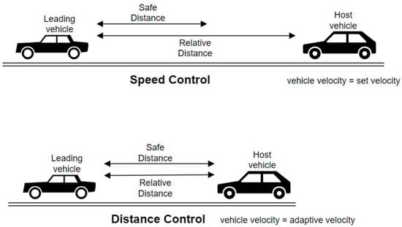

Figure 3: Working modes of adaptive cruise control (ACC in Electric Vehicles with Field-Oriented Control)

*Speed Control Mode*:

In the speed control mode, the host vehicle travels at the driver-set speed (V_set). The ACC system's control goal is to track this desired velocity.

Distance Estimation in Speed Control Mode: The ACC system continuously measures the relative distance (D_rel) between the host vehicle and the lead vehicle using the radar sensor. If D_rel is greater than the safe distance (D_safe), the system stays in speed control mode. The ACC control algorithm calculates the required throttle position to maintain the driver-set velocity (V_set) based on the current speed and acceleration of the host vehicle.

*Distance Control Mode*:

If the lead vehicle comes too close, the ACC system switches from speed control to distance control mode. The control goal is now to maintain a safe distance (D_safe) from the lead car.

*Distance Estimation in Distance Control Mode*:

The ACC system continues to measure the relative distance (D_rel) between the host vehicle and the lead vehicle using the radar sensor. If D_rel is less than the safe distance (D_safe), the system switches to distance control mode. The ACC control algorithm calculates the required throttle position and/or applies the brakes to keep a safe following distance (D_safe) from the lead vehicle.

*Mode Selection*:

The ACC system continuously evaluates the relative distance (D_rel) to determine the appropriate control mode. If D_rel is greater than D_safe, the ACC system stays in speed control mode to maintain the driver-set velocity (V_set). If D_rel is less than D_safe, the ACC system switches to distance control mode to maintain a safe distance from the lead vehicle.

* 1. Actuators

**Throttle Actuator**: The throttle (in ICE) actuator is responsible for controlling the engine throttle position. When the ACC system needs to accelerate the vehicle it sends commands to the throttle actuator to increase engine power.

**Brake Actuator**: The brake actuator controls the vehicle's braking system. If the ACC system determines that vehicle needs to slow down or stop it send signals to brake actuator to engage the brakes appropriately.

* 1. Human Machine Interface (HMI)

HMI includes multiple points for driver to interact with such as display, controls, warnings, visual or audible notifications and customization.

* + 1. Display

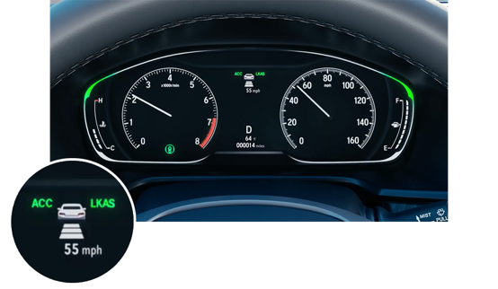 One of the critical elements of the HMI is the display, typically located in the vehicle's instrument cluster or infotainment screen. The display presents important information related to the ACC system, such as current set speed, vehicle current speed, set following distance and activation status (whether it is activated or deactivated). To convey this information visually, the display may use easily recognizable icons or animations, makes it easy for the driver to understand the system operation at a glance. By providing this information in a clear and concise manner, the display ensures that the driver remains informed about the ACC-related parameters without distraction.

Figure 4: Display Instrument Cluster

* + 1. Controls

Physical controls or touch-sensitive buttons dedicated to ACC functions are another essential part of the HMI. These controls are often strategically placed on the steering wheel or center console for easy access. Common buttons include ACC On/Off (A & C) to activate or deactivate the ACC system, Set (B) to establish the desired cruising speed, "Res/+" (E) to resume or increase speed, "Coast/-" (D) to decrease speed and "Distance" to modify the following distance setting. The design and placement of these controls are thoughtfully considered to ensure that the driver can operate them conveniently while keeping their attention focused on the road.

*Figure 5: Stering Control Interface*

* + 1. Visual Cues, Driver warnings and Customization

In the Human-Machine Interface (HMI), multiple features contribute to a better driving experience. One such valuable visual cue is the representation of the following distance setting, displayed using bars or icons to show the space between the driver's vehicle and the one in front. The number of bars or icons corresponds to the selected following distance level (e.g., short, medium, long), allowing the driver to understand and adjust the Adaptive Cruise Control (ACC) system's sensitivity to the vehicle ahead, aligning it with their comfort level and driving conditions.

Additionally, the HMI plays a crucial role in conveying important messages and warnings to the driver. For example, if the ACC system detects a potential collision with the vehicle ahead, it issues a Forward Collision Warning (FCW), accompanied by a warning message and audible alert, prompting immediate action from the driver. In situations where the ACC system cannot maintain the following distance due to traffic or other factors, the HMI notifies the driver to resume manual control of the vehicle.

Moreover, the HMI allows for further customization of ACC preferences, with drivers choosing between different modes (e.g., normal, eco, sport) based on their preferences and adjusting the level of sensitivity in maintaining the set following distance. Some vehicles even offer memory settings, allowing multiple drivers to save their preferred ACC configurations, enhancing the personalized driving experience for everyone.

# Use cases / Features

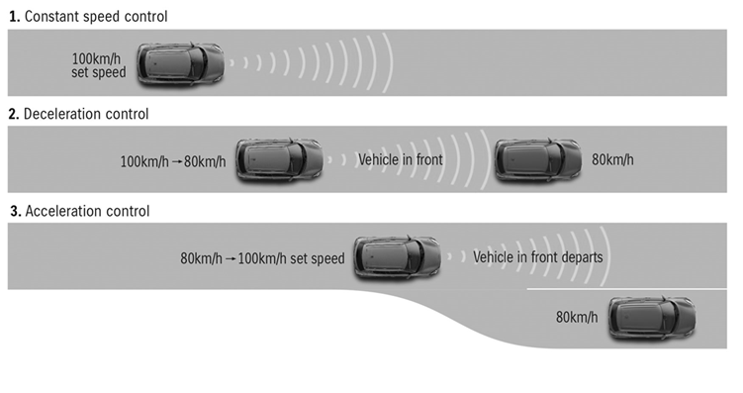

Figure 6: Use cases

* 1. Intelligent Collision Avoidance

The goal is to relieve the driver from the routine of spacing adjustments at cruise speeds on highways.

A crucial component of applications for emergency braking and adaptive cruise control (ACC) is intelligent collision avoidance. It makes use of advanced sensor technologies, clever algorithms, and decision-making systems to identify potential collision hazards and avoid traffic accidents.

As soon as a potential collision is detected, second stage come into play (Deceleration control), where the host vehicle starts to slow down, in addition to Proactive measurer are swiftly implemented like the light indicator start to display alongside sound warning. These measures may help guiding the vehicle to a safer position, where the third stage (Acceleration control) starts, in which the host vehicle start to accelerate again. State-of-the-art control systems facilitate these actions without delay. It also tries to maximize safety while minimizing interference with traffic movement.

Figure 7: Intelligent Collision Avoidance

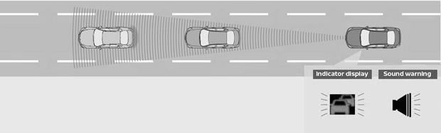

How Intelligent Collision Avoidance works:

* The Radar, lidar, and cameras are just a few of the sensors used to continuously scan the environment. They gather information in real time on the location, motion, and proximity of adjacent objects, people, and moving vehicles
* After the sensor data is gathered, it undergoes processing by cognitive algorithms and decision-making systems.
* These systems carefully examine the data, considering variables like relative speeds, distances, and projected paths. By incorporating factors such as vehicle behavior, road conditions, and traffic flow, they evaluate the likelihood of collisions.

The benefits of intelligent collision avoidance are that It reduces human error, driver attention, and delayed reaction times by offering proactive intervention and real-time crash notifications.

The limitations of Intelligent Collision Avoidance must be understood also. The system's performance may be impacted by poor weather, sensor limitations, and unforeseen events (Al-Smadi et al., 2020).

* 1. ACC Stop and Go

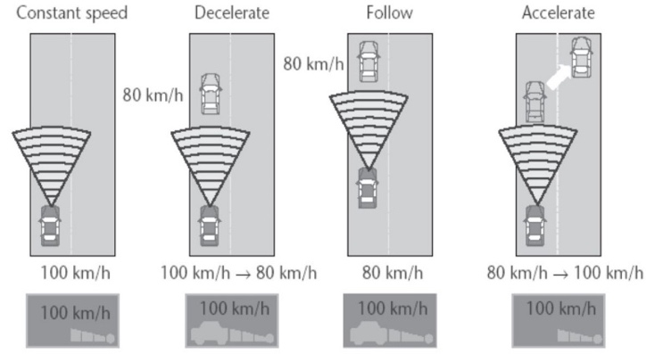

Figure 8: Operating mode(ACC Stop and Go) (source: Nissan)

ACC (Adaptive Cruise Control (ACC) is an advanced cruise control system that adjusts a vehicle's speed to maintain a safe distance from the car in front. It utilizes radar and camera sensors to detect slower or stopped vehicles ahead and calculates the required deceleration or braking to maintain a preset following distance. It addresses the difficulties caused by clogged roads and frequent pauses, it is a crucial application of emergency braking and adaptive cruise control (ACC) technologies (Persson et al., 1999).

**Key points about ACC stop-and-go functionality:**

* ACC uses sensors to detect slower or stopped vehicles ahead and calculates required deceleration or braking. It automatically reduces throttle and applies brakes to slow down when the lead vehicle does.
* The system aims to match the lead vehicle's speed while maintaining a desired following distance.
* The driver can override ACC by braking or accelerating if necessary.

**Benefits of ACC stop-and-go:**

* Decreases driver workload and tiredness by automating speed adjustments and maintaining a safe following distance.
* Reduce fuel consumption.

**Development of ACC sensors:**

* ACC's initial focus was on detecting vehicles at greater distances (over 10 meters).
* The Stop and Go extension require comprehensive coverage of nearby range (up to 30 meters), which can't be achieved with a single front-facing sensor.

Gunter et al. suggested a torque monitoring control strategy for adaptive cruise control in vehicles during stop-and-go traffic. By comparing various torque inputs, it calculates the final demand torque, preventing slipping and delays in monitoring signals, thus enhancing driving safety. The paper also introduces ACCwSG (**ACC** **W**ith **S**top and **G**o), aiming to maintain minimum safety and inter-vehicle distances using an ideal offline optimization technique based on Dynamic Programming. This approach, especially effective in hybrid electric vehicles, helps reduce fuel consumption by regulating energy usage during braking (Gunter et al.,2020.).

* 1. Automatic Emergency Braking

AEB, is a crucial safety innovation designed to reduce the severity of accidents caused by delayed driver response. Human drivers often struggle to react quickly in stressful situations, increasing the risk of collisions. When a collision is unavoidable, AEB engages the brakes to minimize the impact.

AEB requires a comprehensive understanding of the vehicle's braking performance, handling characteristics, and stability control capabilities. This information enables the system to determine the appropriate braking pressure and maneuvers to reduce collision impact (Xu et al., 2015).

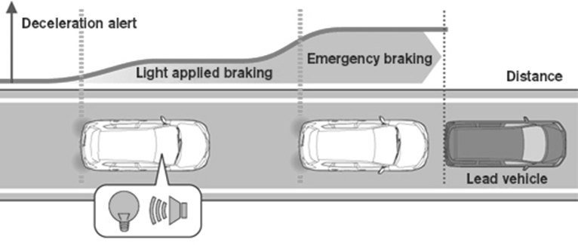

Figure 9: Operating mode (ACC AEB) (source: Nissan)

The (AEB) system in autonomous electric vehicles is one example of a safety-critical system whose performance has been improved by the development of control algorithms. A low-level control module, an intermediate-level switching algorithm, and a high-level Rule-Based Supervisory control module make up the hierarchical AEB control system that the authors suggest. The switching algorithm is used by the Rule-Based supervisor to identify the necessary deceleration command and feed it to the low-level control module. Two-wheel slip control algorithms were created at the low level, a Gain-Scheduled Linear Quadratic Regulator and a Robust Sliding Mode control technique incorporating an Artificial Neural Network (ANN) for nonlinear parameter estimation (Gounis & Bassiliades, 2022).

To meet the requirements of this control design, a non-linear dynamic vehicle model was used instead of considering the constant tire-road friction coefficient (Intelligent Momentary Assisted Control for Autonomous Emergency Braking, 2021).

* 1. Lane keeping assistance

The combination of Adaptive Cruise Control and Lane Keeping Assistance (LKS) is a promising advancement in advanced driver support systems. ACC adjusts a vehicle's speed to maintain a safe distance from the leading vehicle, while LKS helps keep the vehicle centered in its lane using vision-based cameras by notifying the driver first, then correcting the host vehicle direction which depends on vehicle speed and angle of divergence. (Bian et al., 2020).

**Benefits of ACC with LKS:**

Figure 10: Operating mode (ACC LKA)

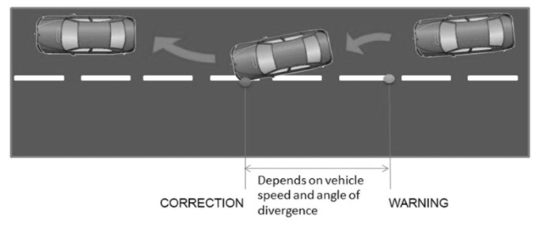

* Reduced Risk of Accidents.
* Improved Driver Comfort.
* Increased Fuel Efficiency.

**Challenges of ACC with LKS:**

* Sensor Limitations: Duo to severe weather conditions, poor road markings.
* Driver Awareness: To maximize the benefits of ACC with LKS, drivers must remain alert and aware of the system's limitations.

# Capabilities

* 1. Recognition of curve contour

In Recognition of curve contour usually a curve is characterized by static objects like guard railings, pillars, trees, buildings, etc., that marks the curve contour. The signal processing of the ACC sensor produces a simple but nevertheless representative picture of the situation, detecting the different objects with their main characteristics like position, width, relative speed, etc (Sánchez et al., 2001).

**The key features of curve detection and recognition in ACC include:**

* Smooth acceleration and deceleration.
* Dynamic steering assistance, they can provide subtle steering inputs to help the driver navigate through the curves more effectively.
* Intelligent curve tracking enables the system to make real-time adjustments to ensure that the vehicle remains on the intended path.
* Adaptation to various curve types.
  1. Detect unequivocally stationary objects

ACC uses a variety of sensor technologies to precisely identify stationary objects on the road. The sensors continuously scan the area, collecting data in real-time and providing a detailed picture of all the objects present.

The algorithms used by ACC can identify and distinguish between fixed and moving objects like cars that have stopped at a stoplight or pedestrians who are waiting to cross the street. This can be done by analyzing the sensor data to determine the accurate speed and direction of each object.

When a stationary object is identified, ACC will use the sensor measurements, that have been gathered, to determine the distance between the host vehicle and the object. This distance estimate is crucial for maintaining a safe following distance. ACC can then modify the vehicle's speed and acceleration so that it avoids approaching or colliding with the stationary object.

If ACC determines that a collision with a stationary object is imminent, it will activate intelligent collision warning systems. These systems will provide visual and audible alarms to the driver to warn them of the potential danger. In some cases, ACC may also initiate automated emergency braking to avoid or lessen a collision with the stationary object (Park et al., 2017).

* 1. Adaptive Speed Limit Assistant

The Speed Limit Assistant (SLA) is a useful feature integrated into ACC systems that provides drivers with increased information and guidance about speed limits on the road. This functionality is supplemented by the SLA feature, which focuses on speed limit awareness and adherence.

To perceive and understand speed limit signs along the road, the SLA normally employs a combination of sensors, including cameras and GPS. The sensors continuously scan the area, recognizing speed limit signs and collecting data in real time. The SLA then utilizes this information to calculate and show the current speed limit to the driver.

In addition to visual displays, the SLA may also provide speed limit violation notifications to the driver. These notifications, which may be visual or audible, are designed to remind the driver of the speed limit and encourage them to adhere to it.

Drivers must remain vigilant of the speed limit and exercise sound judgment when operating their vehicles.

# Limitation

* 1. Human Factor Issues

A poorly designed and overly sensitive system can increase a driver’s workload, which as a result can decrease driver’s situation awareness, comfort, and even safety. A very good understanding of the driver’s psychology and behavioral habits is therefore essential.

In the same direction Goodrich et al. emphasize that safe and effective ACC design requires that the operational limits of ACC be detectable and interpretable by human drivers. They count four basic factors for safe operation of ACC (Kyriakidis et al., 2019) (Goodrich et al.,1999).

Additionally, the system must be designed to maintain the driver's trust in the system:

* The feeling of Losing of control because the driver must feel in control of the vehicle at all times.
* Trust in which the driver must trust the collision avoidance system to work properly.
* Situational awareness is where the driver must be aware of the potential for a collision to take evasive action.
* Workload is where the collision avoidance system must not increase the driver's workload.
  1. Rage of Operation

While ACC provides significant advantages, specific operational constraints have been enforced to ensure optimal performance and driver acceptance. These constraints have been investigated, highlighting their importance in ensuring safety and comfort during automated driving scenarios (Winner et al., 1996).

* Lower Speed Limit.
* Time Constant Bounds, in which the time constant in ACC refers to the time it takes for the system to modify the vehicle's speed to match that of the previous vehicle.
* Restrictions on Active Braking.
* Maximum Positive Acceleration: With that the ACC system may give a smooth and predictable driving performance, improving the overall driving experience for the occupants.
  1. The longitudinal range of optical sensors duo to weather conditions

Weather conditions have a greater influence on the longitudinal range of optical sensors than on radar sensors. Bad weather conditions, like rain, fog, or snow, can impair optical sensor performance, rendering them "blind" under some situations (Ziran et al., 2020).

It is important to note the following:

* Optical sensors are limited in both the longitudinal and lateral axes.
* Weather conditions have a greater impact on optical sensor performance than on radar sensors.
* Manufacturers and developers of autonomous systems must consider these constraints while building and implementing sensor fusion solutions.
  1. Geometrical obstructions

Due to geometrical obstructions, all contemporary autonomous range sensors have intrinsic limits. These obstructions can reduce the sensors' longitudinal range, or the distance over which they can detect items in front of the vehicle. They can also limit the sensors' lateral range, or the distance over which they can detect things to the sides of the vehicle (Winner et al., 1996).

Some examples of geometrical obstructions that can limit the range of autonomous ranging sensors include:

* Hills and valleys
* Crash barriers
* Walls
* Other side structures
* Vehicles in adjacent lanes

When ACC systems encounter geometrical impediments, they may have trouble accurately detecting the lead vehicle's speed, distance, and trajectory. As a result, the system may struggle to maintain a safe following distance and adjust the speed accordingly.

* 1. Difficulties in predicting the course far in front of you

ACC systems rely on sensors and algorithms to predict the course of objects far ahead. However, there are two main limitations to this:

* Errors in determining road curvature
* Non-constant road segments

To address these challenges, ACC systems primarily focus on the region directly in front of the vehicle, limiting their field of view and range for objects further down the road. As a result, it becomes challenging for the system to notice and predict objects that are farther away (Kyriakidis et al., 2019).

# Examples

* 1. Tesla

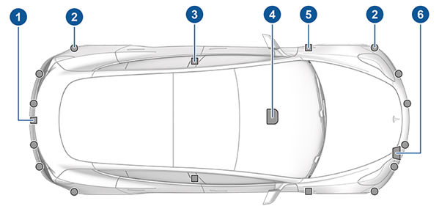

Figure 11: Tesla

Tesla vehicles equipped with Autopilot include ACC functions that allow for automatic speed adjustment and following distance control. The technology uses mostly cameras, and complex algorithms to maintain a safe distance from the vehicle in front of you and adjust your speed accordingly. The feature is known as Traffic-Aware Cruise Control (BETA version). They employ many cameras (Ultrasonic and Radar if available).

* 1. AUDI

Audi Adaptive Cruise Control (ACC): Audi's ACC framework combines radar and camera sensors to screen the road and change the vehicle's speed and following distance. The framework can recognize and react to stationary objects, and it can also be coordinated with Audi's Activity Stick Help, providing further assistance in congested activity situations. It is called Stop and Go Adaptive Cruise Control. It makes use of two radar sensors mounted at the front of the vehicle.

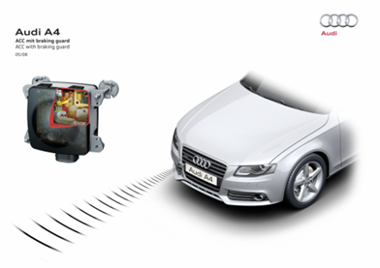

Figure 12: Audi

* 1. BMW

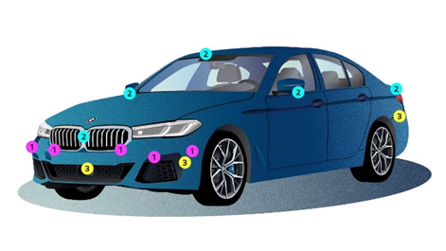

Figure 13: BMW

It's known as ACTIVE Cruise Control with Stop and Go. Ultrasonic, cameras, automotive radar, and LIDAR are all used. BMW's ACC system employs radar and camera sensors to keep an eye on the road ahead. It has automated speed control and can maintain a set distance from the vehicle in front of it. The device also features a stop-and-go feature, which allows the automobile to come to a complete stop and then resume driving in congested regions.

* 1. VOLVO

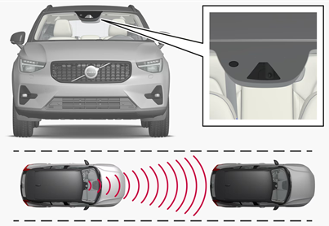

Figure 14: Volvo

It's called Pilot Assist. It uses both a camera and a radar sensor. Volvo Adaptive Cruise Control (ACC) additionally employs radar and camera sensors to monitor the road ahead of the vehicle and adjust speed and following distance as needed. Volvo's ACC technology goes one step further with its Pilot Assist feature, which combines ACC with lane keeping assistance. The technology can assist the driver with steering, acceleration, and braking to make driving more comfortable.

* 1. Mercedes-Benz

Mercedes-Benz DISTRONIC, an advanced driver assistance framework, makes use of radar and camera innovation to keep an eye on the road ahead. The framework may manage the vehicle's speed and, if necessary, bring it to a complete stop to maintain a safe separation from the vehicle in front. DISTRONIC also emphasizes Dynamic Directing Help, which provides the driver with additional help in maintaining route position.

# Future

* 1. Functional Improvements

The primary area of improvement in ACC lies in enhancing the performance of the radar sensor. The radar sensor is responsible for detecting and tracking vehicles and obstacles on the road to enable the ACC system to maintain a safe following distance and adjust the vehicle's speed accordingly (Ziran et al., 2020). The following functional improvements are expected in ACC:

* Increased Longitudinal and Lateral Range.
* Improved Object Separation Capacity.
* Radar Imaging.
* Integration of Video Systems.
* Challenges and Ongoing Research regarding algorithm optimization.
  1. Integration Aspects

To further advance ACC, integration with sophisticated vehicle systems is being explored. The aim is to allow other vehicle systems to utilize the Longitudinal Control function of ACC (Zhang & El-Gohary, 2017). The integration of ACC with other vehicle systems offers several benefits:

* Streamlining System Interactions, which leads to more efficient communication and coordination among various systems, resulting in improved overall vehicle control.
* Decreasing Redundancy is when ACC's Longitudinal Control function is decoupled from its Electronic Control Unit (ECU), other vehicle systems can utilize this function, reducing redundancy in system design.
* Simplifying the System which allows for a more efficient allocation of resources and a consistent and coordinated approach to vehicle control across various platforms.
  1. Improvements with the navigation system through Predictive Navigation Data

The integration of navigation systems into driver assistance systems, including ACC, offers several advantages (Westerlund et al., 2019):

* Precise Route Prediction, in which navigation systems utilize digital road maps and satellite technologies to precisely determine the vehicle's position and predict the likely track ahead.
* Real-time Traffic Information in the navigation systems can provide real-time traffic information, including speed limits and road design.
* Dependence on High-Quality Digital Maps for accurate navigation system use in driver assistance systems, high-quality digital maps that reflect frequent updates of the road network are required.
  1. Improvements through Image processing

Combining a camera with image processing technology enhances the functionality of ACC in several ways (Wei et al., 2019.):

* Traffic Sign Recognition (TSR).
* Road Line Identification.
* Enhanced Road Environment Understanding.
  1. Cooperative Collision Avoidance

Cooperative Collision Avoidance (CCA) involves integrating ACC systems across multiple vehicles to enable communication and coordination for crash avoidance and improved road safety (Fukatsu & Sakaguchi, 2021).

Some key aspects of CCA include:

* Vehicle-to-Vehicle (V2V) and Vehicle-to-Infrastructure (V2I) Communication.
* Levels of Evasion which means communicating their intentions to neighboring vehicles.
* Advanced Sensor Technologies using Artificial Intelligence and Machine Learning the CCA can utilize AI and machine learning algorithms to assess and predict the behavior of other road users, enabling proactive collision avoidance strategies.

# Discussion

The Report provides an overview of adaptive cruise control, outlining its system requirement and architecture, capabilities, limitations, examples and Future outlook. An important motivation is ACC’s overall capabilities to enhance and improve the driver comfort, road safety and fuel efficiency through automatically adjusting the vehicle speed and the safe following distance from the lead vehicles. The introduction summarized how ACC was build up by combining sensors and control algorithms to adapt to the traffic conditions.

The literature review focused on the evolution history of the ACC back to the early distance warning systems in the 1990s to the present-day proliferation across vehicles models. It shows also how the ACC system was improved alongside the sensors, expanding from LIDAR and radar to multi-sensor fusion.

The paper argued the ACC application requirements how it emphasized the key capabilities needed for effective ACC system. In addition to, how the system architecture integrates sensors, electronic control unit, actuators and human-machine interface, which all combine provide a strong technical framework to develop an ACC system that is safe and reliable.

Furthermore, while designing an ACC system architecture, human-machine component continues to be a key factor. It is a constant challenge to achieve a balance between helpful system feedback and excessive driver disengagement or distraction. The goal of HMI systems should be to maintain driver confidence and readiness to regain control when necessary. Improved interaction models might be facilitated by new driver monitoring technology, such as gaze tracking and emotion detection.

Nevertheless, poor lighting, terrible road condition and unfavorable weather can all compromise sensor performance and impair ACC's ability to perceive. These Limitations may be mitigated by next-generation radar, LIDAR, and cameras with increased robustness to environmental variability and advanced sensor fusion algorithms. It also offers to use artificial intelligence and machine learning to be able to do complex object classification and trajectory forecasting.

Additionally, through vehicle-to-vehicle and vehicle-to-infrastructure communication, cooperative collision avoidance exhibits enormous potential to enhance ACC capabilities. Coordinated evasive movements between networked vehicles become possible by combining sensor data and communicating driving intent. Standardizing communication methods and thorough validation testing are required to realize this potential.

Although substantial advancements have improved ACC, autonomous driving is still a longer-term goal that calls for gradual improvements in perception, planning, and control. Nevertheless, ACC will continue to spread because it is a landmark technology that provides noticeable improvements in terms of safety and convenience.